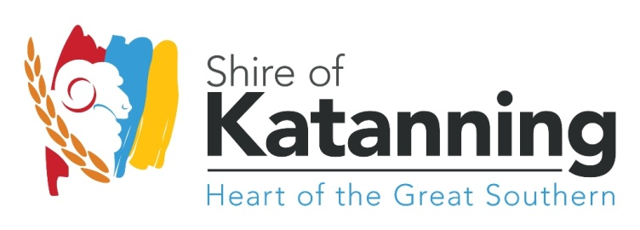

APPLICATION TO SPONSOR A FLAG

SPONSORSHIP PROCESS AND RESPONSIBILITIES:
The flag poles in the Katanning Lions Park proudly display some of the diverse nationalities living in town. Please complete this form to sponsor a flag.
- The cost to sponsor a flag is $100.00 AU per flag, once this form has been completed, you will be contacted to confirm your details and sent an invoice.
- The sponsorship period is for the ‘life of the flag’ which is usually 3-6 months.
- Once a flag has been sponsored, ownership of the flag belongs to the Shire of Katanning.
- At the end of the sponsorship period, you will be offered the opportunity to re-sponsor the flag.
- The flag sponsorship is to represent “living cultures in Katanning”, which is defined as:
languages, food, dress, traditions, music and dance that are alive and shared in Katanning.
- The criteria for a nationality/culture to be included as part of the Fly Your Flag project includes:
  - Should be a resident or have recently been resident in Katanning (i.e. not backpackers/visitors etc.)
  - Have practiced at home, shared and/or celebrated their culture while in Katanning

APPLICANT’S DETAILS
Name of Sponsoring Person/Family:

Organisation (if applicable):

Postal Address:

Suburb: Postcode:

Contact number: E-mail:

Would you like to be acknowledged as a sponsor on the Fly Your Flag project website?
- Yes
- No

By completing this form, do you acknowledge that you have read, understand, and agree to the sponsorship process and responsibilities?
- Yes
- No

Applicant:
Full Name:

Signature:

Date:

On completion of this form, please return to the Shire of Katanning’s Community Relations Officer:
Email: natassia.shirazee@katanning.wa.gov.au
Administration Office, 52 Austral Tce Katanning

