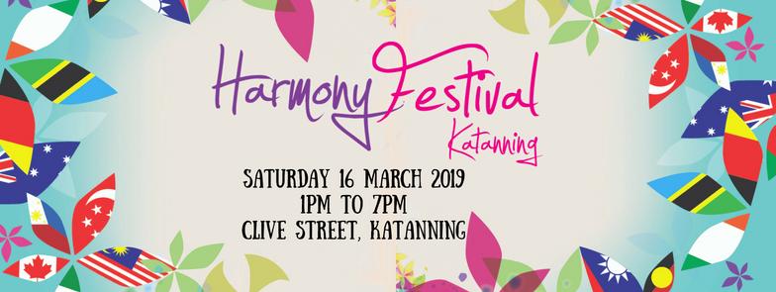
PERFORMANCE APPLICATION FORM

Applications close Friday 15 February 2019

Name of Organisation:
__________________________________________________________________________________________________

Contact Name: Contact Number:
__________________________________________________________________________________________________

Postal Address:
__________________________________________________________________________________________________

Email:
__________________________________________________________________________________________________

- Dance Performance
- Song or Instrumental Performance
- Other_______________________________________

Number of performances: (Max 2) ______________________________________________________________________

Length of entertainment: (Max 10 mins each performance) __________________________________________________

Minimum stage space: _______________________________________________________________________________

Name of performers/group for MC to announce:
__________________________________________________________________________________________________

Please provide a brief introduction/summary for your entertainment: (Max 100 words)
__________________________________________________________________________________________________

__________________________________________________________________________________________________

__________________________________________________________________________________________________

Will you be using an instrument?
- Yes, please specify ____________________________________________________________
- No

Technical Requirements
- CD Player/USB/Aux
- Microphones # _____
- Chairs # _____
- Power, please specify ________________________________________________________

I am aware that my presentation will not be paid, as this is a Not for Profit event. The Festival Team will notify applicants early March 2019 and provide details of allocated performance times.

YOU MUST CHECK IN WITH THE ENTERTAINMENT COORDINATOR AT THE TOWN SQURE 45 MINUTES PRIOR TO YOUR PERFORMANCE TIME SLOT.

Declaration by Applicant
I, the undersigned, certify that I have read and agree to comply with the terms and conditions set out above.

Full Name: Date:
__________________________________________________________________________________________________

Signature: _________________________________________________________________________________________

Additional Information
The Katanning Harmony Festival creates an opportunity for all Western Australians to celebrate what makes each Australian unique and share what we have in common. The continuing message for Harmony Day is that Everyone Belongs, which means all Australians are a welcome part of our country, regardless of their background. It is a time to reflect on where Australia has come from, recognising the traditional owners of this land. It is also about community participation, inclusiveness and respect – celebrating the different cultures that make Australia a great place to live.

No payment will be made for entertainment supplied at the Katanning Harmony Festival, as the festival is Not for Profit event providing free entry and only minimal fees for stall holders.

Please return this document to:
Shire of Katanning
PO Box 130
Katanning WA 6317

admin@katanning.wa.gov.au

For further information please call the Shire Administration on 9821 9999.

For regular Harmony Festival updates please follow facebook.com/KatanningHarmonyFestival

